Name __________________________________ Regents Physics

Classic Circular Force Lab

A link to this lab activity can be found at: <https://www.forestville.com/Page/343>. It is located under Chapter 7 Circular Motion and titled Circular Motion Intro Lab.

**Intro:** This lab will let you determine the speed needed to keep an object in circular motion. You will be able to change the force holding the object in a circle by clicking on the washers (each washer is 10 grams). You can adjust the radius of the circle by clicking on the masking tape that is just below the tube. You can also change the mass of the moving object using the arrows.  
  
**Find the velocity of the object by timing at least 10 revolutions. Then divide your time by 10 to get the time it takes to make 1 rotation (this is the period of motion) When you are ready to start the experiment, click on the begin button.**

**Purpose:** Determine the tangential speed on the rotating object

Determine the centripetal acceleration of the rotating object

Determine the centripetal force of the rotating object.

**Helpful Equations:**

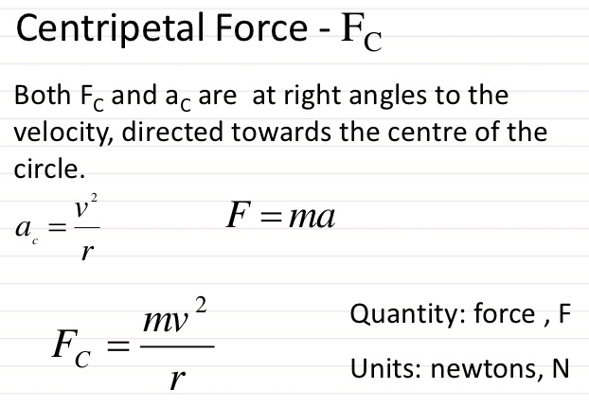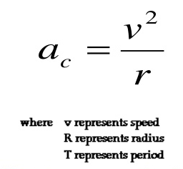 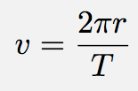

V = velocity (m/s)

r = radius (in meters)

T = period (measured in seconds)

Experiment #1

Set the following conditions:

Moving Mass: 25 g This is also 0.025 Kg. Use this value for the force calculation.

Record the time it takes to make 10 revolutions __________ s Divide by 10 _________ s (period, T)

Using the meter stick record the radius __________ cm Divide by 100 _______ m

Using the radius (r,in meters) and period (T), determine the tangential velocity using the equation in this lab. Show your work below.

Using the tangential velocity and radius, determine the centripetal acceleration in (m/s). Show your work below.

Using the Moving Mass (in kg, not grams), the tangential velocity and radius determine the centripetal force experienced by the moving mass. Show your work below.

Experiment #2

Set the following conditions:

Moving Mass: increase mass to approximately double the value. Write it here in Kg, not grams:

__________ Kg

Record the time it takes to make 10 revolutions __________ s Divide by 10 _________ s (period, T)

Using the meter stick record the radius __________ cm Divide by 100 _______ m

Using the radius (r,in meters) and period (T), determine the tangential velocity using the equation in this lab. Show your work below.

Using the tangential velocity and radius, determine the centripetal acceleration in (m/s). Show your work below.

Using the Moving Mass (in kg, not grams), the tangential velocity and radius determine the centripetal force experienced by the moving mass. Show your work below

Experiment #3

Set the following conditions:

Moving Mass: Same as Experiment #2

Change the Radius to a smaller radius by clicking on the yellow masking tape. Write the new radius here

__________ m

Same as experiment #2 __________ Kg

Record the time it takes to make 10 revolutions __________ s Divide by 10 _________ s (period, T)

Using the meter stick record the radius __________ cm Divide by 100 _______ m

Using the radius (r,in meters) and period (T), determine the tangential velocity using the equation in this lab. Show your work below.

Using the tangential velocity and radius, determine the centripetal acceleration in (m/s). Show your work below.

Using the Moving Mass (in kg, not grams), the tangential velocity and radius determine the centripetal force experienced by the moving mass. Show your work below

Post Lab:

1. Anna Litical is practicing a centripetal force demonstration at home. She fills a bucket with water, ties it to a strong rope, and spins it in a circle. Anna spins the bucket when it is half-full of water and when it is quarter-full of water. In which case is more force required to spin the bucket in a circle? Explain using an equation as a "guide to thinking."
2. 2. A Lincoln Continental and a Yugo are making a turn. The Lincoln is four times more massive than the Yugo. If they make the turn at the same speed, then how do the centripetal forces acting upon the two cars compare. Explain.